State Machine Diagram  
&  
Test Cases

Parameshwaran K - 2022503509

Pavithran S - 2022503705

Inbavanan K - 2022503507

**State Machine Diagram**

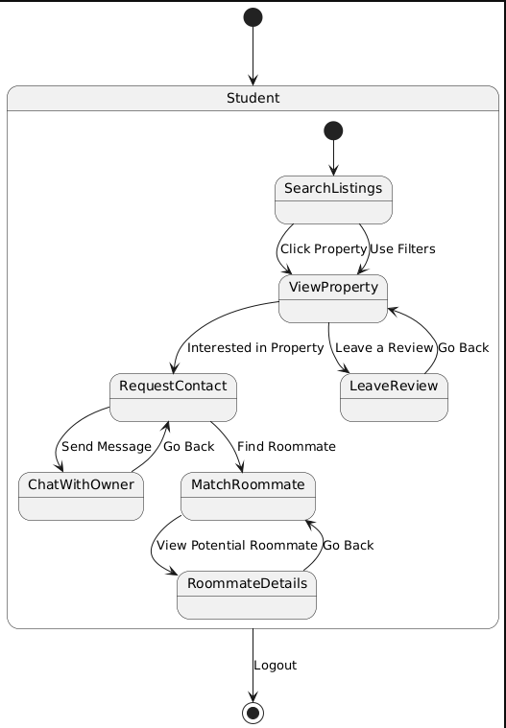

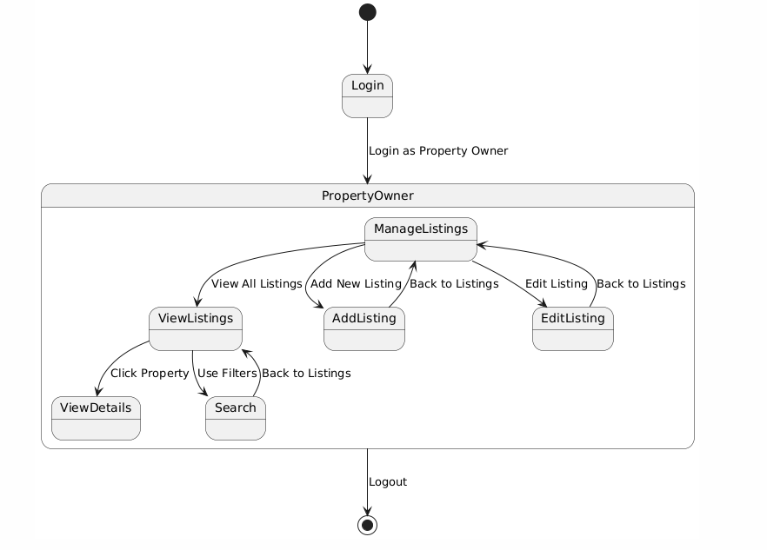

Test Cases

Creating a Tester Class to test Register Module:

Register Page contains Several Testers (Listed Below) :

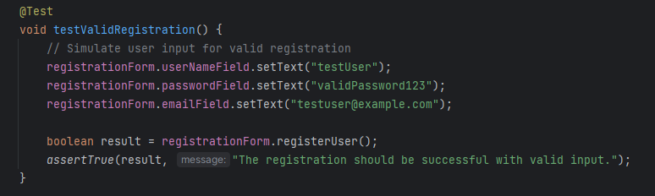

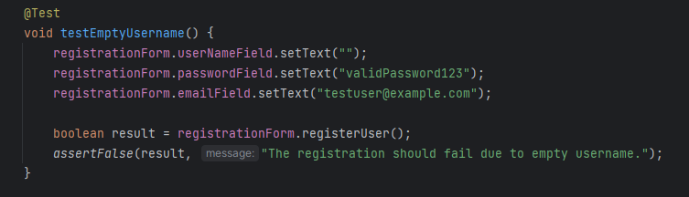

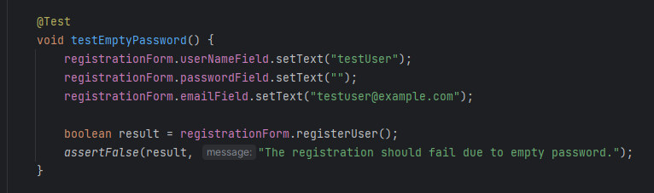

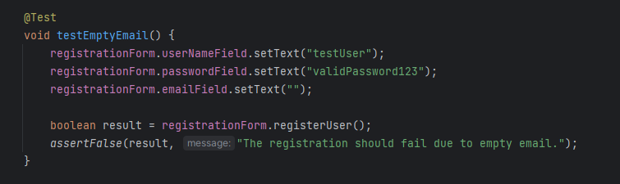 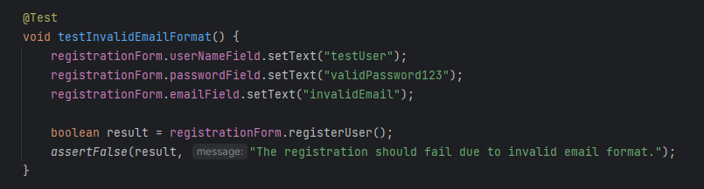

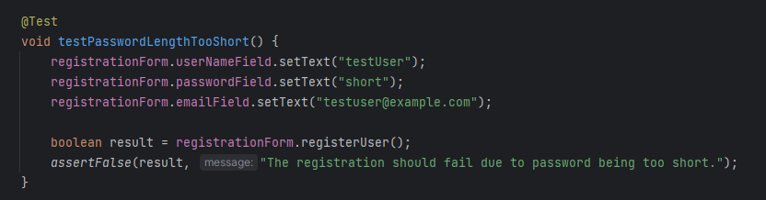

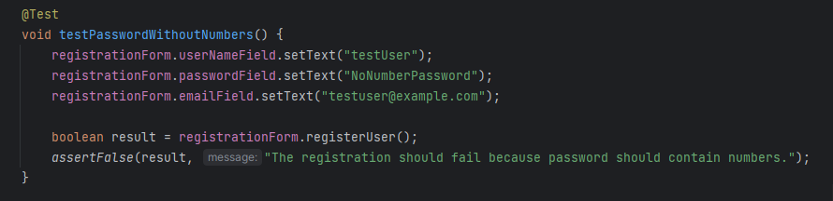

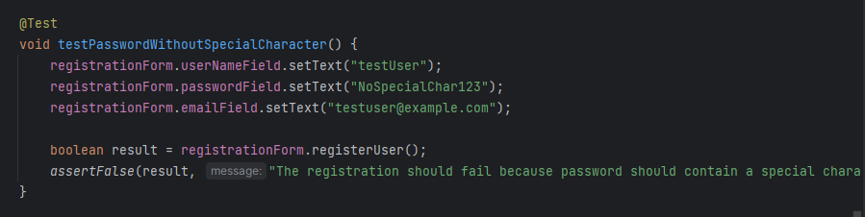

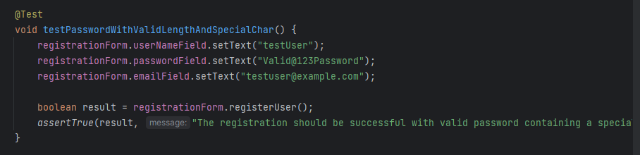 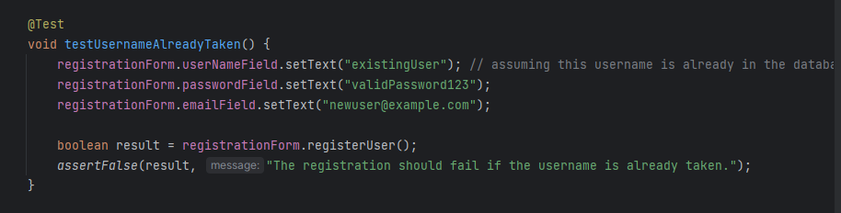

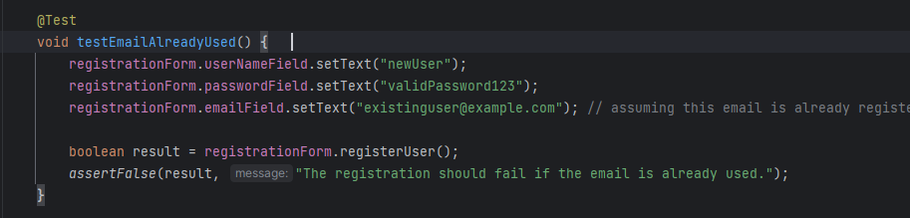

Driver to run the Test Methods:

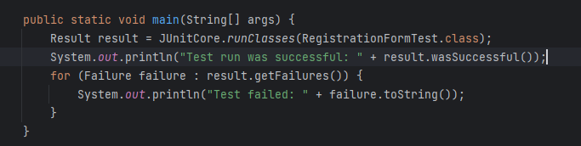

Final Result of All the Test Cases:

